E-commerce Dataset Analysis – Missing Values, Duplicates, Highest-Priced Products, and City-wise Revenue

- Missing Values: Use isnull() and sum() to identify and count missing values in every column. Report possible causes and suitable handling methods.
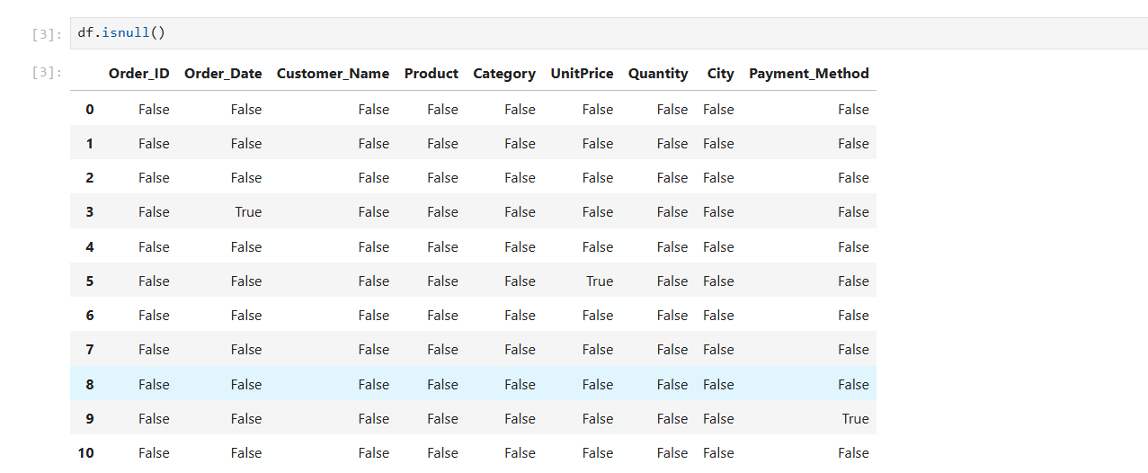
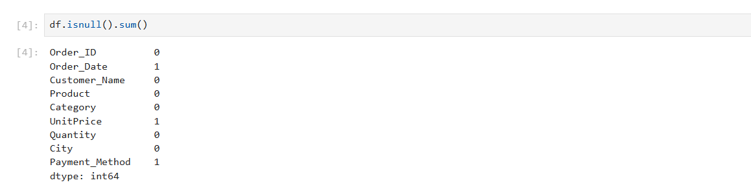

Possible causes:
- Order_Date: The date may not have been recorded during order placement or may have been lost during data import.
- UnitPrice: The product price may be missing due to an incomplete transaction record or a data-entry error.
- Payment_Method: The payment method may not have been captured because of an incomplete checkout process or a system error.
Solutions:
- For Order_Date, retrieve the correct date from the original order records. If it cannot be recovered, consider removing the affected record if the date is essential to the analysis.
- For UnitPrice, retrieve the actual price from the product catalogue or transaction history. If unavailable, use the median price of comparable products only when appropriate.
- For Payment_Method, check the payment transaction logs. If the value cannot be recovered, replace it with "Unknown" rather than assuming a payment method.

- Duplicate Orders: Identify repeated Order ID values, investigate duplicate records, and remove duplicate rows where appropriate. Report the causes and solutions.

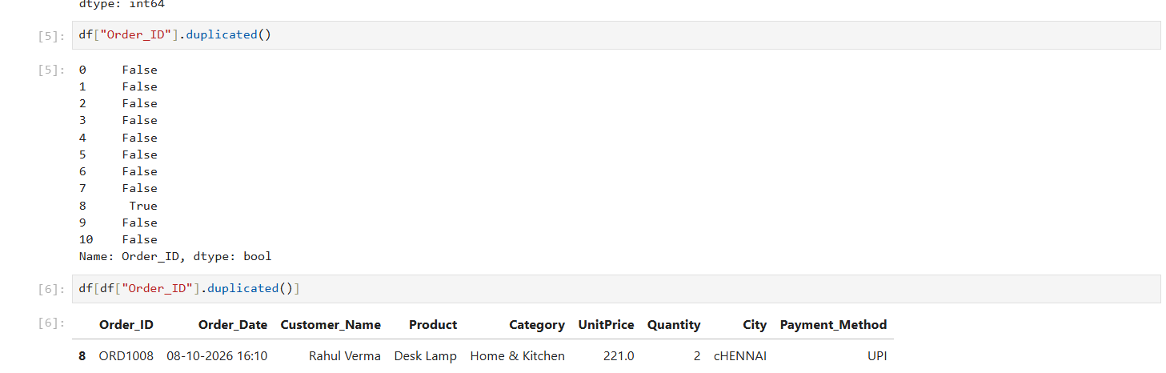
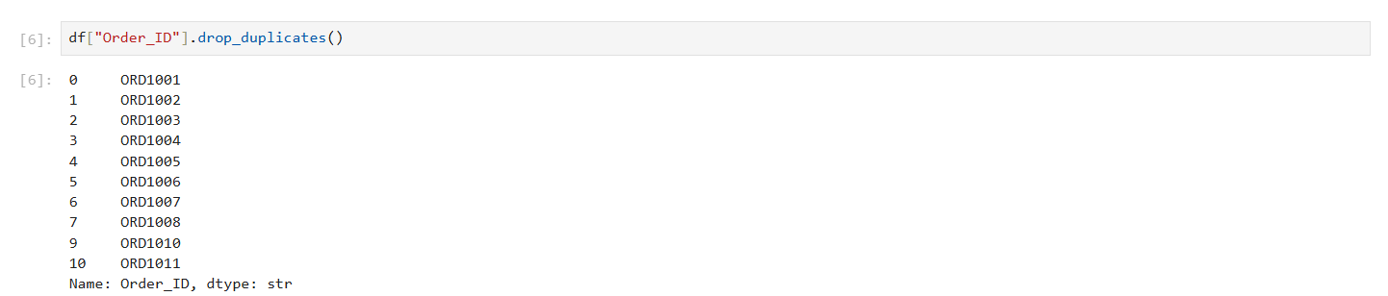

Possible causes:
- The same order may have been entered into the dataset more than once.
- Duplicate records may have been introduced during data import or merging.
- A system retry may have inserted the same transaction twice.
- The same order ID might legitimately contain multiple items if the dataset records individual order items rather than complete orders.
Solutions:
- Inspect all records with the same Order_ID to determine whether they are exact duplicates.
- If the records are identical and represent the same transaction, remove the duplicate rows.
- If the same order ID contains different products, investigate the data structure before removing any records.
- Use a unique transaction identifier or a combination of relevant columns to identify genuine duplicate transactions.

- Highest-Priced Product: Identify the product with the highest available UnitPrice and report its price.
Possible causes:
- A typing error during data entry.
- An incorrect decimal position.
- A currency conversion or data-import error.
- A legitimate high-value product, depending on the business context.
Solutions:
First, identify the product associated with the maximum price:
Next, verify the price against the original product catalogue or transaction records.
If the price is incorrect, correct it using the verified value. If it is legitimate, retain it. Do not automatically replace it merely because it is unusually large.

- City-wise Revenue: Group revenue by City or location using Pandas groupby() and calculate total revenue for each city.
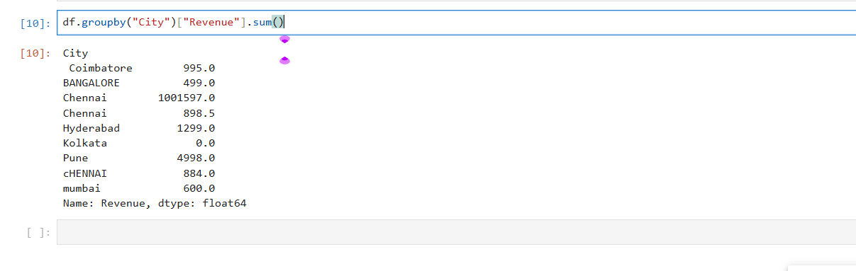
Possible causes:
- Inconsistent city names: Chennai, CHENNAI, and cCHENNAI may refer to the same city but are treated as separate groups.
- Unusually high revenue: Chennai's revenue may be inflated by the unit price of 999999.0.
- Zero revenue: Kolkata's zero revenue may be caused by a missing unit price being filled with zero, a zero-priced item, or another data-quality issue.
- Missing values: Missing prices can result in missing revenue, which may affect the aggregation.
Solutions:
- Standardize city names - This converts variations such as CHENNAI and chennai to Chennai. However, misspellings such as cCHENNAI may need explicit correction.

